Week 4 Report

1. Time Log and Executive Summary

Progress this week
- Located and verified one genuine 24-patch colour-reference image for each of the three cameras in UF_Herp_3998.
- Tested the Imageomics histogram-matching pipeline on the real references and rejected it for production use because improved histogram agreement coincided with visible colour casts and worse patch error.
- Implemented augenblick color: it rectifies the chart, samples corresponding patches, fits a regularized 3 by 3 transform in linear RGB, and applies one transform per camera.
- Processed all 276 photographs and masks in UF_Herp_3998 with no skipped files while preserving dimensions, masks, and sampled EXIF metadata.
- Ran a controlled 36-image masked-COLMAP regression with identical images, masks, and settings except for colour calibration.

Key results
Table 1. Colour and sparse-reconstruction results for the controlled pilot.
Metric | Original | Calibrated | Change
Camera 2 mean patch Delta E76 (lower is better) | 9.218 | 3.131 | -66.0%
Camera 3 mean patch Delta E76 (lower is better) | 3.698 | 1.432 | -61.3%
Registered images | 36 / 36 | 36 / 36 | No change
Verified feature inliers | 28,084 | 28,658 | +2.0%
Sparse points | 3,845 | 3,929 | +2.2%
Mean reprojection error (px; lower is better) | 0.670 | 0.676 | +0.006

Interpretation: the patch error fell for both non-reference cameras. All 36 images still registered after calibration, and inlier + sparse-point counts increased slightly. Also the 0.006 px reprojection-error change is small and should be treated as neutral rather than as an improvement.

Next week
- Add clipping measurements restricted to specimen masks and define a defensible warning threshold.
- Run the same colour and masked-COLMAP checks on a second specimen if per-camera reference-chart images are available.
- Confirm the ColorChecker make and patch-value edition before extending relative camera alignment to absolute calibration.
- Compare the 3 by 3 linear model with a higher-order method only if held-out evaluation shows a clear gain without clipping or colour casts.

Blockers
Table 2. Current blockers, their impact, and the evidence needed to resolve them.
Blocker | Impact | Resolution
Unknown chart edition | Absolute calibration cannot yet be claimed; the current result is relative camera alignment. | Confirm the physical chart make and patch-value edition.
Background-dominated clipping | Whole-image clipping percentages cannot serve as an acceptance threshold. | Compute clipping only inside each specimen mask.
Single-specimen validation | The current evidence does not support a general claim across specimens or dense reconstruction. | Repeat on another specimen and add a dense or mesh-level comparison.

2. Literature Review

Preserving colour fidelity in photogrammetry [1]
Question and method: Barbero-Alvarez et al. examine how acquisition, RAW development, colour spaces, chart-based calibration, and texture generation affect colour fidelity in cultural-heritage photogrammetry.
Finding: Colour must be treated as a controlled and measurable property of the pipeline. Visual appearance alone is insufficient; known chart patches should be evaluated after processing.
Relevance: This supports reporting patch error and clipping alongside qualitative before-and-after images, and it argues for preserving a reproducible record of every colour transformation.

Root-polynomial colour correction [2]
Question and method: Finlayson et al. compare ordinary 3 by 3 linear correction with polynomial and root-polynomial alternatives for mapping camera RGB values to reference values.
Finding: A linear transform is simple and exposure-independent. Ordinary polynomial terms may introduce exposure-dependent hue shifts, whereas root-polynomial terms retain exposure scaling while offering additional flexibility.
Relevance: The pilot deliberately begins with the lower-complexity 3 by 3 model. A higher-order method should only replace it if held-out chart patches show a meaningful gain without increased clipping or visible artefacts.

Imageomics colour-calibration software [3]
Method: The Imageomics package uses segmented colour cards and per-channel histogram matching to normalize a target image to a reference image.
Evaluation: On the museum reference images, histogram distances improved but patch accuracy and full-image appearance did not improve consistently. Visible colour casts appeared in corrected images.
Decision: Histogram matching was rejected for the current capture process. Corresponding chart patches provide a stronger calibration signal because the optimization is tied to known colour locations rather than only to global channel distributions.

3. What I Did and How I Verified It

3.1 Located the usable reference data
Objective: Determine whether the specimen archive contained a real colour reference for each camera.
Method: Searched the repository and archived specimen data, then visually checked the candidate frames and masks.
Evidence: One genuine 24-patch chart frame was confirmed for each of cameras 1, 2, and 3 in UF_Herp_3998.
Decision: Use camera 1 as the relative target until the physical chart model and reference-value edition are confirmed.

3.2 Evaluated the existing Imageomics approach
Objective: Test whether the available open-source pipeline could be adopted directly.
Method: Ran the software on explicit chart masks and compared channel histograms, chart-patch error, and the appearance of full corrected images.
Evidence: Histogram convergence improved, but camera 2 patch error rose from 12.39 to 17.99 Delta E76 and the corrected images showed visible casts. Camera 3 improved only modestly, from 25.61 to 23.05.
Decision: Reject histogram matching as the production method for this dataset.

3.3 Implemented corresponding-patch calibration
Objective: Align the three cameras using measurements from corresponding chart patches.
Method: Rectify each chart from four reviewed corners, sample the 24 patch interiors, convert RGB values to linear light, and fit one regularized 3 by 3 transform per non-reference camera.
Evidence: Camera 2 mean patch error fell from 9.218 to 3.131 Delta E76 and camera 3 fell from 3.698 to 1.432.
Decision: Accept the linear relative-calibration method for wider testing while retaining the unmodified originals.

3.4 Validated file preservation and reconstruction behaviour
Objective: Ensure that calibration does not damage the dataset contract or destabilize sparse reconstruction.
Method: Processed all 276 image-mask pairs and ran original versus calibrated masked-COLMAP reconstructions on the same 36-image subset.
Evidence: No photographs were skipped; reference-camera files and masks remained byte-identical; corrected JPEG dimensions and sampled EXIF fields were preserved. Both COLMAP runs registered 36 of 36 images.
Decision: The pilot passes the file-integrity and sparse-reconstruction gate. Dense or mesh-level evaluation remains future work.

4. Results Visualization
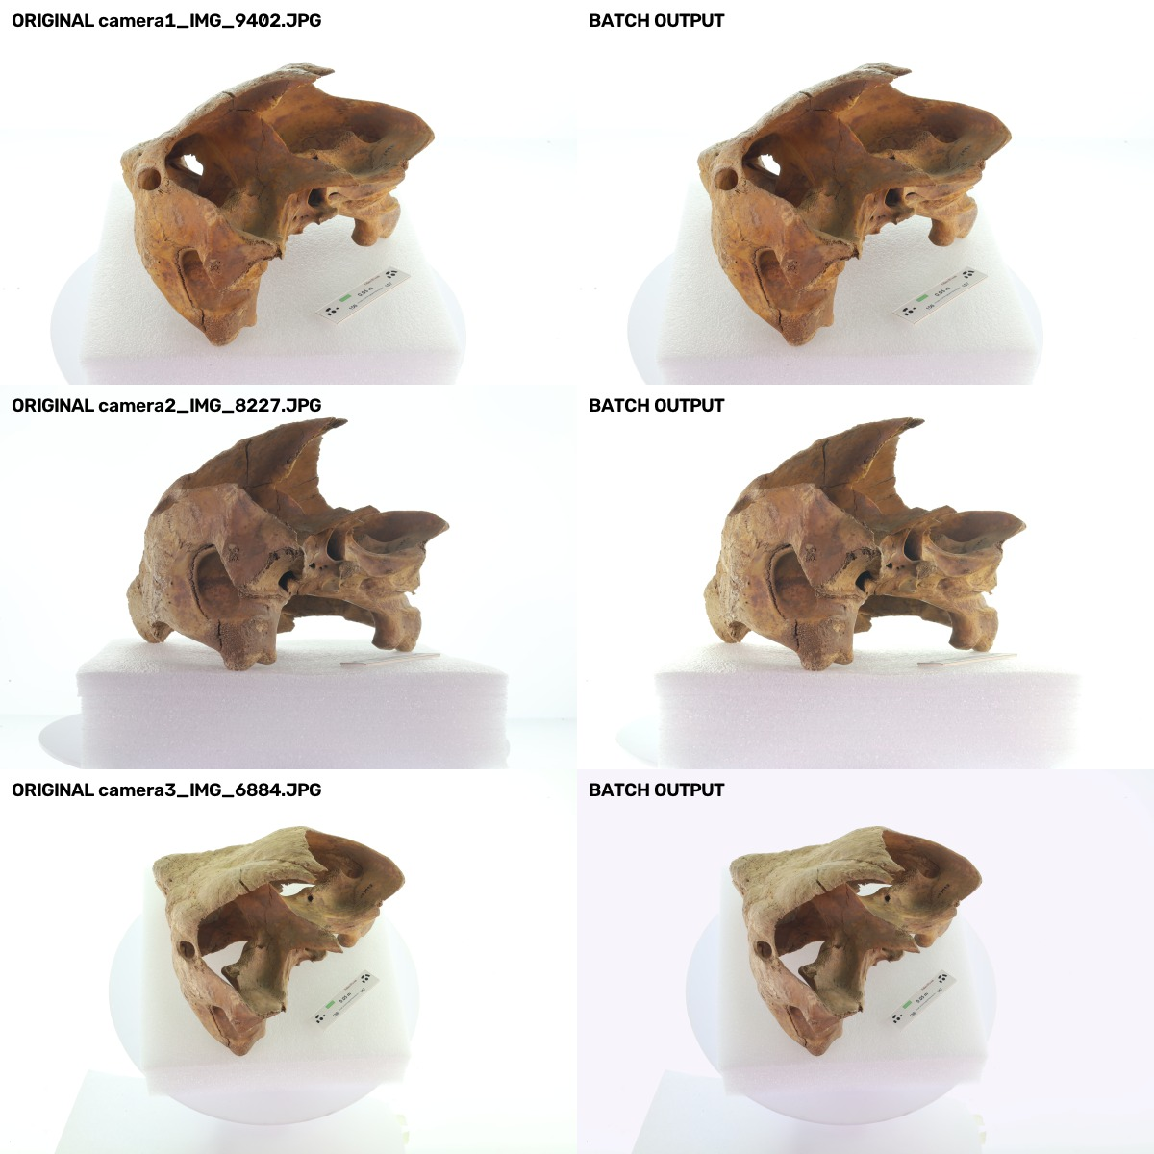
Figure 1. Representative images from the three-camera batch before and after corresponding-patch calibration. The accepted method reduces cross-camera disagreement without the visible cast produced by histogram matching.
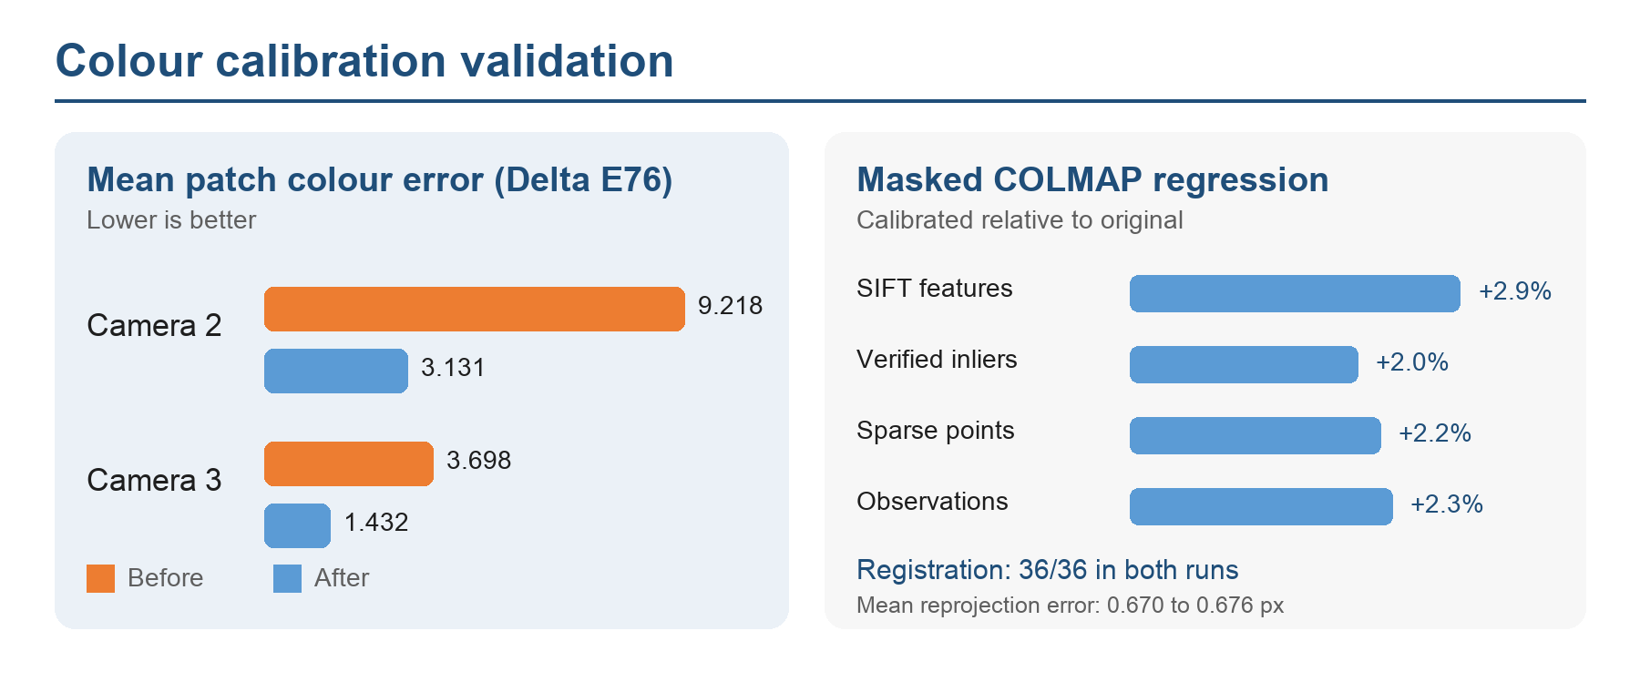
Figure 2. Calibration reduced mean chart-patch Delta E76 by 66.0% for camera 2 and 61.3% for camera 3. The controlled masked-COLMAP regression retained 36 of 36 registrations and changed sparse reconstruction metrics only slightly.

5. Conclusions and Decisions
- Adopt corresponding-patch, per-camera linear calibration as the current pilot method.
- Do not adopt per-channel histogram matching for this dataset; histogram agreement was not a reliable proxy for colour accuracy.
- Describe the current output as relative camera alignment, not absolute calibration, until the chart edition is confirmed.
- Treat sparse reconstruction as preserved rather than improved; the small metric changes do not establish a geometric benefit.
- Require specimen-mask clipping, a second specimen, and dense or mesh-level evaluation before making a general production recommendation.

Evidence and artifacts
Pilot and decision record: documentation/color-calibration-pilot-2026-09-21.md
Implementation: team-repo/src/augenblick/preparation/color.py
Example configuration: team-repo/examples/color/uf_herp_3998.json
Full-batch evidence: outputs/color-calibration-report-uf-herp3998-full-2026-09-22.json
COLMAP regression: outputs/color-calibration-colmap-regression-2026-09-22.json
Visual comparison: outputs/color-calibration-batch-real-images-2026-09-22.jpg

6. References
[1] M. A. Barbero-Alvarez, S. Brenner, R. Sablatnig, and J. M. Menendez, “Preserving colour fidelity in photogrammetry,” Heritage, vol. 6, no. 8, pp. 5700-5718, 2023. https://doi.org/10.3390/heritage6080300
[2] G. D. Finlayson, M. Mackiewicz, and A. Hurlbert, “Color correction using root-polynomial regression,” IEEE Transactions on Image Processing, vol. 24, no. 5, pp. 1460-1470, 2015. https://doi.org/10.1109/TIP.2015.2405336
[3] Imageomics Institute, color-calibration software repository. https://github.com/Imageomics/color-calibration (accessed September 23, 2026).

